Dr. Ken’s Electrotechnology Equation Sheets V4

- How to answer calculation questions accurately and clearly.
- Rounding using engineering notation and use 3/4 significant figures for your final answer.
- Make all quantities clear using both Magnitude and direction (if any) (E.g. 23.4 A <25 Deg Lag.)
- Include the units by name or symbol (E.g. A or Amps)
- Highlight your answer by underlining in Red or putting a red box around the answer.
- Label your answer clearly. (E.g. Q2/b )

- Rounding to 3 significant figures …the basic rules.
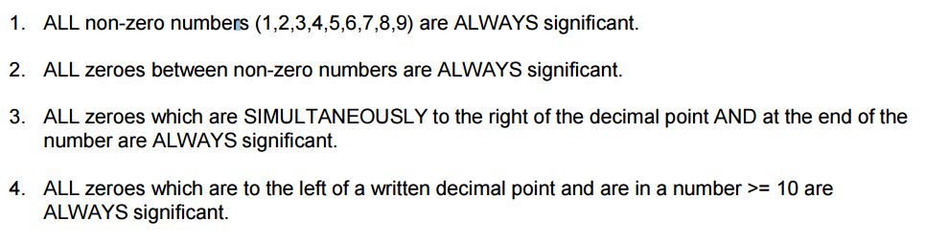

Rounding examples | Three significant figures | Four significant figures
11,567.34 Volts | 11.6 Kv | 11.57 Kv
172.64 Amps | 173 Amps | 172.6 Amps
12.45 Ohms | 12.5 Ohms | 12.45 Ohms
1.7622 Watts | 1.76 Watts | 1763 mW
0.13569 Amps | 136 mA | 135.7 mA
0.0003725 Ohms | 3.73 m Ohms | 3.725 m Ohms
0.00001234 Amps | 12.3 micro Amps | 12.34 micro amps

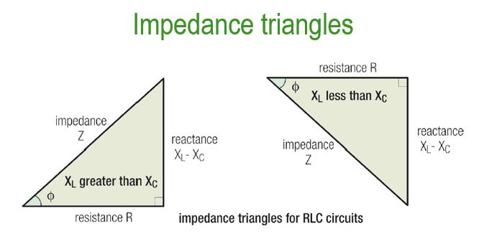
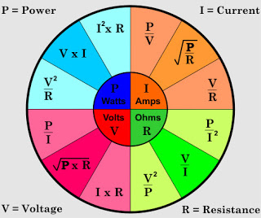
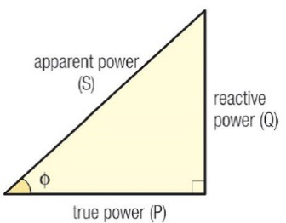

Power Triangle
Students Name:
