AC Resources provided by;



This Subject and Study guide is written to be used in association with the AC training videos provided on Wired4Imagination.com

SUBJECT & STUDY GUIDE:

Solve Problems in Low Voltage A.C. Circuit
National ID |  | Unit of Competency (UoC) Name
UEENEEG102A |  | Solve Problems in Low Voltage A.C. Circuits

For additional information – see Training.gov.au link

  Year and Semester: | Semester 2 2019
  Prerequisites: | - UEENEEE101A Apply Occupational Health and Safety regulations, codes and practices in the workplace  - UEENEEE104A Solve problems in D.C circuits  - UEENEEG101A Solve problems in electromagnetic devices and related circuits
  eLearn: | Wired4Imagination.com
  Teacher Name(s) and Contact Details: | Dr. Ken Meyer 0419226478 Kenneth.meyer55@gmail.com

Subject Summary:
This unit covers ascertaining correct operation of single and three phase a.c. circuits and solving circuit problems as they apply to servicing, fault finding, installation and compliance work functions. It encompasses safe working practices, multiphase circuit arrangements, issues related to protection, power factor and MEN systems and solutions to circuit problems derived from calculated and measured parameters.

Assessment:
You will need to complete the following assessment items to be successful in this subject/s. Further details regarding assessment items will be provided by your teacher.

No | Assessment Name – brief description of assessment | Dates
Skills Assessment Portfolio Part 1 | SA#1a – Single Phase a.c. Circuit – CRO measurements (40 min)  SA#1b – Single Phase Series RLC a.c. Circuit (40 min)  SA#2 – Single Phase Parallel RLC a.c. Circuit (40 Hour)  Information for Students: You may have two (2) attempts for this assessment within the allotted time.  If your first attempt is not successful, your teacher will discuss your results with you and then make a second attempt.  If your second attempt is not successful, you will be required to re-enrol in this unit again.  Only one re-assessment attempt will be granted for each assessment item.  Time Allowed: 2 Hours Total  Materials Provided: Practical training aids and all required measuring instruments.  Assessment Range and Conditions:  The Assessment will be conducted during regular class time in a 4 hour block.  All work must be the students own work  Student may have a copy of AS3000, Textbook “Electrical trade principles”, internet access, equation sheet.  Student must supply their own calculator, pens pencils and drawing equipment.  Student may not use or have access to: smart phone, unit workbook, personal notes.  Assessment Criteria: To achieve a Satisfactory result, your assessor will be looking for your ability to demonstrate the key skills/tasks/knowledge detailed in the Assessment Task to industry standard at all checkpoints.  A result of 100% in every assessment point is a Satisfactory Result. This is a limited open book assessment | Session 9
Skills Assessment Portfolio Part 2 | SA#3a – Three Phase Unbalance Star Connected Load (1 Hours)  SA33b – Three Phase Delta Connected Load (1Hours)  Information for Students: You may have two (2) attempts for this assessment within the allotted time.  If your first attempt is not successful, your teacher will discuss your results with you and then make a second attempt.  If your second attempt is not successful, you will be required to re-enrol in this unit again.  Only one re-assessment attempt will be granted for each assessment item.  Time Allowed: 2 Hours Total  Materials Provided: Practical training aids and all required measuring instruments.  Assessment Range and Conditions:  The Assessment will be conducted during regular class time in a 4 hour block.  All work must be the students own work  Student may have a copy of AS3000, Textbook “Electrical trade principles”, internet access, equation sheet.  Student must supply their own calculator, pens pencils and drawing equipment.  Student may not use or have access to: smart phone, unit workbook, personal notes.  Assessment Criteria: To achieve a Satisfactory result, your assessor will be looking for your ability to demonstrate the key skills/tasks/knowledge detailed in the Assessment Task to industry standard at all checkpoints.  A result of 100% in every assessment point is a Satisfactory Result. This is a limited open book assessment | Session 17
KA1 | Knowledge Assessment Lessons 1-6 (Unit Topics 1 to 7).  Information for Students: You may have two (2) attempts for this assessment.  If your first attempt is not successful, your teacher will discuss your results with you and will arrange a second attempt. As part of the second attempt all relevant topic quizzes must be complete with 100% achieved before the re-sit.  If your second attempt is not successful, you will be required to re-enrol in this unit.  Only one re-assessment attempt will be granted for each assessment item.  Supplementary evidence maybe used by and at the discretion of the assessor (Teacher) for the successful completion of a topic point. Supplementary evidence is the “Physics Exercise booklet” and the “Practical booklets”. For these to be valid sources of evidence, all work for a particular topic MUST have been completed correctly in the exercise and or practical booklets prior to assessment.  Time Allowed: 3 Hours  Materials Provided: Working out paper  Assessment Range and Conditions:  The Assessment will be conducted during regular class time in a 4 hour block.  All work must be the students own work.  Student may have a copy of and must provide their own, of AS3000, AS3008, Textbook “Electrical trade principles”, internet access (), clean equation sheet.  Student must supply their own calculator, pens pencils and drawing equipment.  Student may not use or have access to: smart phone, unit practical workbook, personal notes.  Student must provide their own device for all on-line assessments.  Assessment Criteria: To achieve a Satisfactory result, your assessor will be looking for your ability to demonstrate the key skills/tasks/knowledge detailed in the Assessment Task to industry standard.  A result of 100% in every topic is a Satisfactory Result. This is a limited open book assessment.  Books you may use and you must provide are: Textbook, AS3000, AS3008, and Clean Equation Sheet.  You must also provide all pens, pencils, drawing equipment and a calculator. | Session 8
KA2 | Knowledge Assessment Lesson 7-12 (Unit Topics 8 to 15)  Information for Students: You may have two (2) attempts for this assessment.  If your first attempt is not successful, your teacher will discuss your results with you and will arrange a second attempt. As part of the second attempt all relevant topic quizzes must be complete with 100% achieved before the re-sit.  If your second attempt is not successful, you will be required to re-enrol in this unit.  Only one re-assessment attempt will be granted for each assessment item.  Supplementary evidence maybe used by and at the discretion of the assessor (Teacher) for the successful completion of a topic point. Supplementary evidence is the “Physics Exercise booklet” and the “Practical booklets”. For these to be valid sources of evidence, all work for a particular topic MUST have been completed correctly in the exercise and or practical booklets prior to assessment.  Time Allowed: 3 Hours  Materials Provided: Working out paper  Assessment Range and Conditions:  The Assessment will be conducted during regular class time in a 4 hour block.  All work must be the students own work  Student may have a copy of and must provide their own, of AS3000, AS3008, Textbook “Electrical trade principles”, internet access (), clean equation sheet.  Student must supply their own calculator, pens pencils and drawing equipment.  Student may not use or have access to: smart phone, unit practical workbook, personal notes.  Student must provide their own device for all on-line assessments.  Assessment Criteria: To achieve a Satisfactory result, your assessor will be looking for your ability to demonstrate the key skills/tasks/knowledge detailed in the Assessment Task to industry standard.  A result of 100% in every topic is a Satisfactory Result. This is a limited open book assessment. | Session 16
KA3  Quiz portfolio | Lesson Quizzes 1 to 12 Portfolio.  Information for Students: You may have unlimited number of attempts for this portfolio assessment.  You must complete this portfolio of topic quizzes on or before the second last week of the semester.  All topic quizzes must be complete with 100% achieved in each.  Time Allowed: One semester (17 weeks) Due the week of SA#2 at the very latest.  Materials Provided: KA#3 Assessment booklet  Assessment Range and Conditions:  The Assessment will be conducted at the students discretion.  All work must be the students own work  Student may have a copy of AS3000, Textbook “Electrical trade principles”, internet access, equation sheet.  Student must supply their own calculator, pens pencils and drawing equipment..  Student must provide their own device for all on-line assessments.  Assessment Criteria: To achieve a Satisfactory result, your assessor will be looking for your ability to demonstrate the key skills/tasks/knowledge detailed in the Assessment Task to industry standard.  A result of 100% in every topic is a Satisfactory Result. This is a unlimited open book assessment.

What you will need:
To be successful in this subject you must have all the following resources:
- Drawing Set (Compass (large Span), protractor, 30mm ruler), four colours of pens or pencils. (Black, Red, Blue, Green)

- Scientific Calculator (Preference Casio FX82, FX100, or FX991)

- Multimeter (CAT III or IV) optional.

- Bring your own device (BOD) is required for this unit. All knowledge assessment are web-based and much of the content in the form of Video and Audio podcasts. You must bring your own device to all lessons. .

- For this subject requires the following texts to be purchased including or similar to the following learning resources: Please note that all Audio Podcasts and Videos are based in these texts.
- Phillips, P, Electrical Principles, Cengage Learning, Second Edition.

- Student workbook pack for AC. The workbook is available on-line. Approximate cost is $45.

- TAFE NSW workbook. The workbook is available on-line. Approximate cost is $45.

- AS3000:2018 (Wiring Rules) and AC3008 (Cable Selection)

Schedule:
To be successful in this subject you must engage in a range of activities. It is recommended that, in addition to scheduled classes, you will require between 1-1.5 hours per week for additional learning. You will need the textbook “Electrical Principles 3rd Ed”, by Peter Philips. All podcasts and Video lessons are based on this textbook. You will also be required to have the student practical workbooks and exercise book. Also required are a notebook, graph paper (5mm2) and at least 4 colours of pens or pencils, 30cm ruler, Protector, large reach (span) compass. Failure to come to class without the appropriate tools is tantamount to turning up the job site without your toolbox! Failure to have all the resources listed above by the second week of semester will result in your employer being notified and you should return to work.

Please see your class timetable for further dates, times and classrooms (if applicable).

Session  (Date optional) | What’s on this session
1 | AC Lab Passport (Who to use AC measuring equipment and training aids).    Connecting Series and Parallel AC circuits.  Learning how to learn in Electrotechnology. Cognitive Toolbox.  Student must purchase textbook, Workbook, graph paper, drawing instruments etc.  Three ways to learn AC. Hard Way, Very Hard Way, Vary Hard Long Way.  Revision of Ohms Law, Series, Parallel and combination circuits.
2 | :  Textbook Chapter 15.1 -15.4 (page 332) should be reviewed prior to class, via Video, Reading or Podcast.  AC Lesson #1 Alternating Current Complex Quantities (Parts 15.0 -15.4)  - Trigonometry  - Pythagoras  - CRO Operation  - Sinusoidal Wave Formations
3 | :  Textbook Chapter 15.5 -15.6 (page 346) should be reviewed prior to class, via Video, Reading or Podcast.  .  Lesson #2 Phasors Diagrams, Addition and Subtraction (Parts 15.0-15.5,15.6)  - Phasor Diagrams  - Phasor Relationship  - Using Phasor Diagrams
4 | :  Textbook Chapter 16.1 -16.7 (page 359) should be reviewed prior to class, via Video, Reading or Podcast.  Lesson # 3 Single Element AC Circuits. Pure R,L and C (Parts 16.1-16.2)  - Resistive AC Circuits  - Inductive AC Circuits  - Capacitive AC Circuits
5 | :  Textbook Chapter 17.1 -17.4 (page 378) should be reviewed prior to class, via Video, Reading or Podcast.  Lesson # 4 RC and RL and RLC Series AC Circuits  - Impedance  - RC series AC Circuits  - RL series AC Circuits  - RLC series AC Circuits  - Impedance and Voltage relationships  - Series Resonance
6 | :  Textbook Chapter 18.1 -18.6 (page 401) should be reviewed prior to class, via Video, Reading or Podcast.  Lesson #5 Parallel AC Circuits. (Part 18.1 – 18.6)  - RC Parallel AC Circuits  - LC Parallel AC Circuits  - RLC Parallel AC Circuits  - Parallel Resonance
7 | :  Textbook Chapter 19.1 -19.3 (page 419) should be reviewed prior to class, via Video, Reading or Podcast.  Lesson #6 Power in AC Circuits (Parts 19.1-19.3)  - AC Power  - Power Factor  - AC Single Phase Power measurement
8 | Lesson Topic Quizzes 1 to 7 should be completed and passed prior to Knowledge Assessment 2 being attempted. This sets you up for success.  Knowledge Assessment 1 Lessons 1 – 7 ( Unit Topics 1 – 7 )  Information for Students: You may have two (2) attempts for this assessment.  - If your first attempt is not successful, your teacher will discuss your results with you and will arrange a second attempt. As part of the second attempt all relevant topic quizzes must be complete with 100% achieved before the re-sit. This is KA3 Portfolio.  - If your second attempt is not successful, you will be required to re-enrol in this unit.  - Only one re-assessment attempt will be granted for each assessment item.  - Supplementary evidence maybe used by and at the discretion of the assessor (Teacher) for the successful completion of a topic point. Supplementary evidence is the “Physics Exercise booklet” and the “Practical booklets”. For these to be valid sources of evidence, all work for a particular topic MUST have been completed correctly in the exercise and or practical booklets prior to assessment.  Time Allowed: 2 Hours  Materials Provided: Working out paper, One sheet per question, must have students name and question number!  Must be handed back to the teachers at the end of the assessment  Assessment Range and Conditions:  - The Assessment will be conducted during regular class time in a 4 hour block.  - All work must be the students own work  - Student may have a copy of AS3000  - Student must supply their own calculator, pens pencils and drawing equipment.  - Equation sheet  Assessment Criteria: To achieve a Satisfactory result, your assessor will be looking for your ability to demonstrate the key skills/tasks/knowledge detailed in the Assessment Task to industry standard.  Student may have a copy of AS3000, Textbook “Electrical trade principles”, internet access, equation sheet.  Student must supply their own calculator, pens pencils and drawing equipment.  Student may not use or have access to: smart phone, unit workbook, personal notes.  - A result of 100% or in every topic is a Satisfactory Result
9 | Skills Assessment Portfolio  - SA#1a – Single Phase a.c. Circuit – CRO measurements  - SA#1b – Single Phase Series RLC a.c. Circuit  - SA#2 – Single Phase Parallel RLC a.c. Circuit  Time Allowed: 2 Hours  Materials Provided: All training aids and measurement instruments  Assessment Range and Conditions:  - The Assessment will be conducted during regular class time in a 4 hour block.  - All work must be the students own work  - Student may have a copy of AS3000  - Student must supply their own calculator, pens pencils and drawing equipment.  Assessment Criteria: To achieve a Satisfactory result, your assessor will be looking for your ability to demonstrate the key skills/tasks/knowledge detailed in the Assessment Task to industry standard at all checkpoints.  Resits from Knowledge Assessment 1 if all the applicable lesson quizzes are complete with 100%
10 | :  Textbook Chapter 19.4 -19.5 (page 419) should be reviewed prior to class, via Video, Reading or Podcast.  Lesson #7 Power factor improvement and Harmonics and Resonance revision  (Parts 19.4,19.5 & 20.8)  - Power Factor  - Power Factor improvement  - Harmonics  - Series Resonance  - Parallel Resonance
Sep 30-Oct 4 | Term Break (one week!)
11 | :  Textbook Chapter 20.1 -20.2 (page 436) should be reviewed prior to class, via Video, Reading or Podcast.  Lesson #8 Three Phase Systems Introduction (Parts 20.1 & 20.2)  - Multiphase Systems  - Three Phase Systems
12 | Textbook Chapter 20.3 & 20.5 (page 440) should be reviewed prior to class, via Video, Reading or Podcast.  Lesson #9 Topic 11 Three phase star-connections, Wye, 3&4 Wire.  (Parts 20.3 & 20.5)  - Star Connected Systems  - Star Connected Systems Conditions  - Function of Neutral Conductors  - Neutral Conductors  - Australian Standards Requirements
13 | :  Textbook Chapter 20.4 (page 444) should be reviewed prior to class, via Video, Reading or Podcast.  Lesson #10 Three phase delta-connections, Mesh and Interconnected systems  (Part 20.4)  - Delta Connections  - Delta Systems  - Three Phase Interconnections
14 | :  Textbook Chapter 20.6-20.7 (page 444) should be reviewed prior to class, via Video, Reading or Podcast.  Lesson #11 Energy and power requirements of a.c. systems circuits  (Part 20.6 & 20.7)  - Three Phase Power  - Power Factor  - Measuring Three Phase Power
15 | Teacher Handouts.  Teacher PowerPoint. Should be reviewed prior to class, via Video, Reading or Podcast.  Lesson #12 Earth Fault loop Impedance  - Earth Loop Impedance  - Australian Standards  - Measuring Fault Loop Impedance  Revision General
16 | Lesson Quizzes 8-15 should be completed and passed prior to Knowledge Assessment 3 being attempted. This sets you up for success.  Knowledge Assessment 2 Lesson 7-12 (Unit Topics 8 – 15)  Information for Students: You may have two (2) attempts for this assessment.  - If your first attempt is not successful, your teacher will discuss your results with you and will arrange a second attempt. As part of the second attempt all relevant topic quizzes must be complete with 100% achieved before the re-sit.  - If your second attempt is not successful, you will be required to re-enrol in this unit.  - Only one re-assessment attempt will be granted for each assessment item.  - Supplementary evidence maybe used by and at the discretion of the assessor (Teacher) for the successful completion of a topic point. Supplementary evidence is the “Physics Exercise booklet” and the “Practical booklets”. For these to be valid sources of evidence, all work for a particular topic MUST have been completed correctly in the exercise and or practical booklets prior to assessment.  Time Allowed: 3 Hours  Materials Provided: Working out paper, One sheet per question, must have students name and question number!  Must be handed back to the teachers at the end of the assessment  Assessment Range and Conditions:  - The Assessment will be conducted during regular class time in a 4 hour block.  - All work must be the students own work  - Student may have a copy of AS3000  - Student must supply their own calculator, pens pencils and drawing equipment.  - Equation sheet  Assessment Criteria: To achieve a Satisfactory result, your assessor will be looking for your ability to demonstrate the key skills/tasks/knowledge detailed in the Assessment Task to industry standard.  Student may have a copy of AS3000, Textbook “Electrical trade principles”, internet access, equation sheet.  Student must supply their own calculator, pens pencils and drawing equipment.  Student may not use or have access to: smart phone, unit workbook, personal notes.  - A result of 100% in every topic is a Satisfactory Result
17 | Skills Assessment Portfolio  - SA#3a – Three Phase Unbalance Star Connected Load  - AS#3b – Three Phase Delta Connected Load  Time Allowed: 2 Hours  Materials Provided: All training aids and measurement instruments  Assessment Range and Conditions:  - The Assessment will be conducted during regular class time in a 4 hour block.  - All work must be the students own work  - Student may have a copy of AS3000  - Student must supply their own calculator, pens pencils and drawing equipment.  Assessment Criteria: To achieve a Satisfactory result, your assessor will be looking for your ability to demonstrate the key skills/tasks/knowledge detailed in the Assessment Task to industry standard at all checkpoints.  Resit Knowledge Assessment 2 if all the applicable Lesson quizzes are complete with 100%
18 | Finalisation of Unit and Outstanding Assessments.  All students are to attend class unless notified by the teacher.

Assessment Topic questions mapped to Content in the Textbook
Knowledge Assessment #1 T1 – 7 (Lesson 1-6) | Knowledge Assessment #2 T8 – T15 (lesson 7-12)
T1 : Q1 – Q3 (AC Quantities)(15.1-15.4) | T8 : Q30 - Q33 (Power Factor)(19.4-19.5)
T2 : Q4 – Q5 & Q52 (Phasor diagrams)(15.5-15.6) | T9 : Q34 – Q39 (Resonance and Harmonics)(20.8)
T3 : Q6 – Q12 (Single element RLC)(16.1-16.7) | T10 : Q40 – Q43 (3 Phase Systems)(20.1-20.2)
T4 : Q13 – Q18 (RL-RC Series)(17.1-17.4) | T11 : Q44 – Q46 (Star connections 3 Wire)(20.3-20.5)
T5 : Q19 – Q21 (RLC in series)( 17.1-17.4) | T12 : Q47 – Q51 (Star connections 4 Wire)(20.3-20.5)
T6 : Q22 – Q25 (Parallel AC)(18.1-18.) | T13 : Q53 – Q57 (Delta connections)(20.4)
T7 : Q26 – Q29 (AC Power)(19.1-19.3) | T14 : Q58 – Q60 (3 Phase Power)(20.6-20.7)
 | T15 : Q61 – Q63 (Earth fault loop impedance)(No text)

For study purposes use the subject guides reference to the textbook. Our recommendation is the textbook.
Your exercise tutorial book and practical books are supplementary evidence for assessment, but only if complete with all working out and correct.
Read the last page in the exercise tutorial book, hint hint……
Short form re-sit policy
Knowledge Assessments
1: Attempt 1 passed, all good stop here.
2: KA#3 Topics quizzes 1 -7 for KA#1 or Topics quizzes 8-15 for KA#2 must be to 100% complete.
3: If all required topics of KA#3 at 100% then re-sit in next re-sit week (KA#1 following week, KA#2 two weeks’ latter)
4: If KA#3 not complete to 100% then resit will occur in the resit week at the end of the semester.
Skills Assessments
1: Attempt 1 passed, all good stop here.
2: Attempt 2 is required.
3: The two options offered to the student;
A: Some direction by the assessor and student may make second attempt immediately.
B: Student may stop assessment on that task to the do additional study. Task will be completed in the resit week at the end of the semester.
Additional Information:

Re-assessment – If your assessment work is deemed ‘not-yet-satisfactory’ you will be given one opportunity to re-sit the assessment task or resubmit your assessment work taking into account feedback received from your teacher. For graded subjects, you will be entitled to no higher than a pass for any re-assessed work. See your assessment coversheet for more information.
Assessment Feedback – You will receive assessment results and feedback within two weeks of submitting or completing the assessment tasks. Your teacher will advise you how feedback will be given.

How not to study….
Practicing assessments for the sake of practicing assessments.
This is a fallacy with electronic assessment.
The practice assessment and quizzes cover the same content and concepts but use different question techniques from a vast library bank.
No matter how may practice assessments you do you will never cover all the question types and approached for a particular concept.
Practice quiz or assessment is about finding your learning gaps. Then going back to the content to study the concept you do not yet fully understand.

Cramming before assessments.
Whether it’s doing practice assessments, watching videos, or reading the textbook, cramming is about short term remembering.
Short term remembering is good if we are assessing simple isolated facts. Unfortunately, AC physics is about integrated and layered concepts that interact with each other. So “remembering” a single fact without context, relationship and meaning is useless and a waste of time long term.

Indicative Calendar (May change without notice)

DR. Kens How to add and subtract Phasors on your CASIO calculator: This is part of the equation sheet.
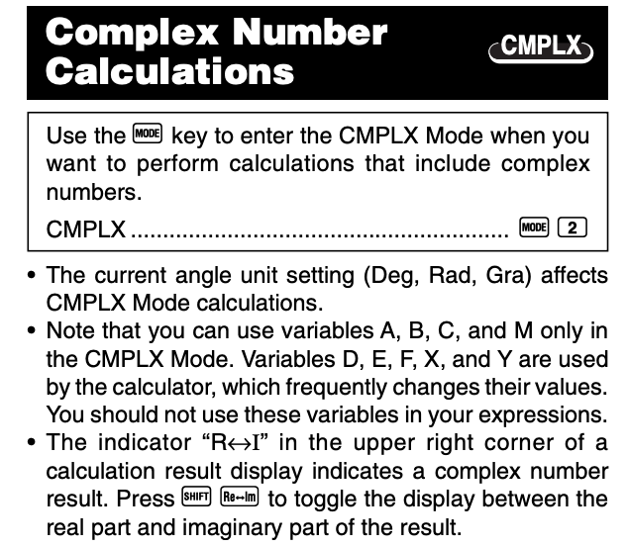

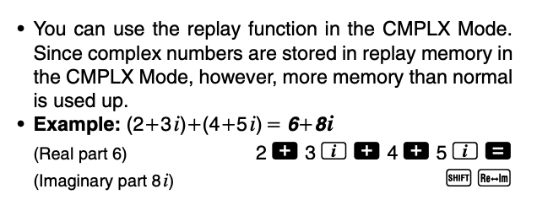

Setting up your calculator:
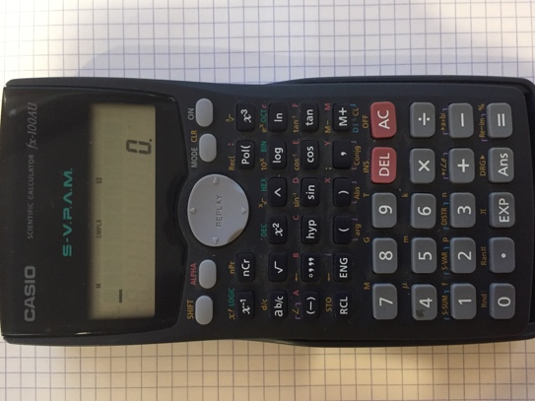
- Mode set to “Complex MODE”.
- Put calculator in Degrees (normally is).

Special Note : FX100 Plus slightly different: Use “COMPX” button to convert answer to Polar.

So let’s do a worked example:

(a) What is the addition of two currents of 12A < -45⁰ and 17 A < -25⁰.
(b) What is the phase angle between the result and the reference?

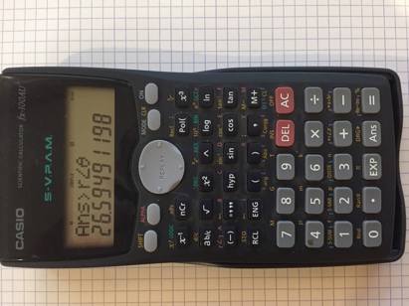
1: Enter : 12<-45 + 15<-25 then =
To obtain “<” Press [SHIFT] [(-)]
2: Answer is displayed in Rectangular
3: Change to Polar Press [SHIFT] [+] =
4: Answer is now in polar r<Ɵ

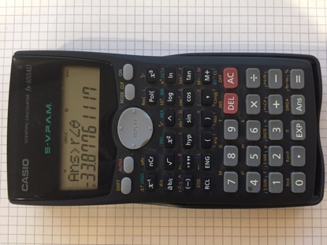
5: To obtain angle from the reference
and shift back and forth with.
Press [SHIFT] [=]
5: Angle is in degrees displayed
(Note the < symbol bottom left)

6: Complete answer: 26A < -33^{O}
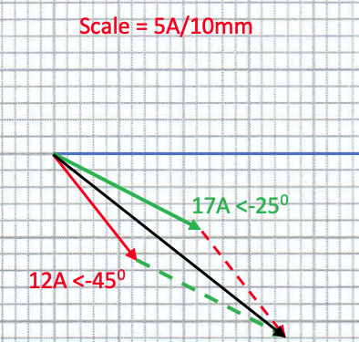
Done with phasor diagram:

26A <-33⁰

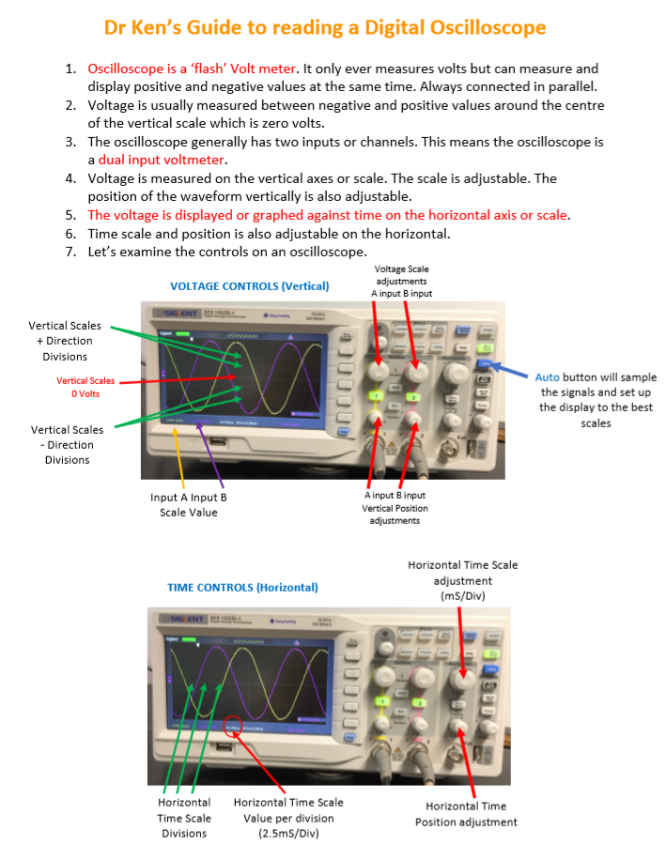

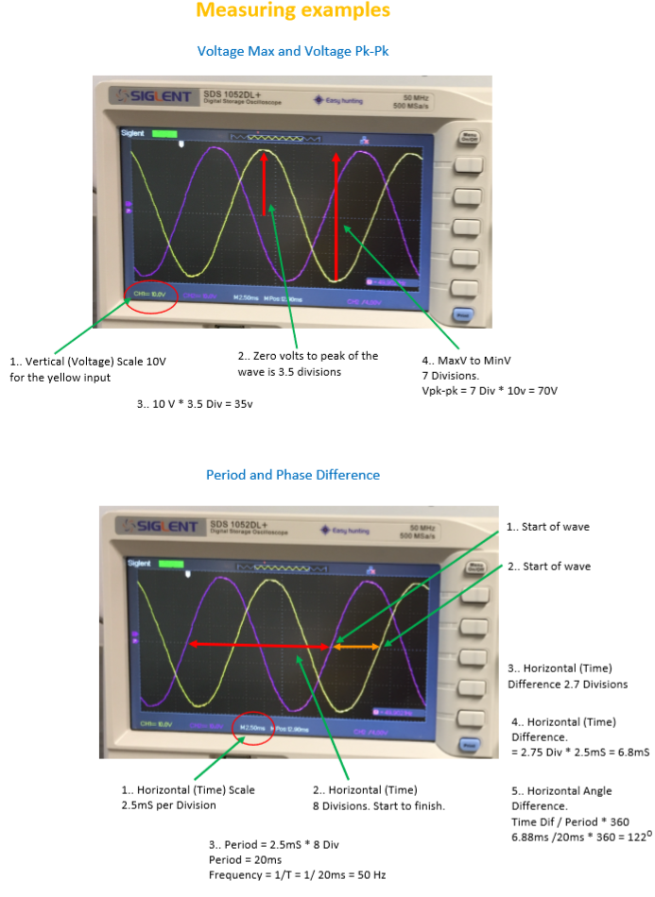
Dr. Ken’s Electrotechnology Equation Sheets V4
- How to answer calculation questions accurately and clearly.
- Rounding using engineering notation and use 3/4 significant figures for your final answer.
- Make all quantities clear using both Magnitude and direction (if any) (E.g. 23.4 A <25 Deg Lag.)
- Include the units by name or symbol (E.g. A or Amps)
- Highlight your answer by underlining in Red or putting a red box around the answer.
- Label your answer clearly. (E.g. Q2/b )

- Rounding to 3 significant figures …the basic rules.
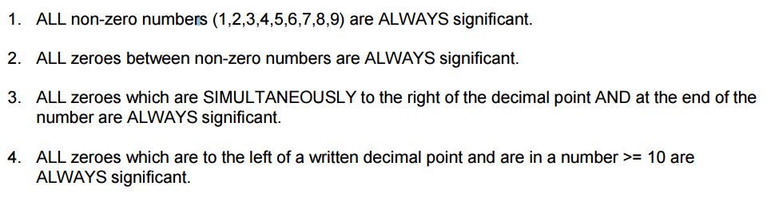

Rounding examples | Three significant figures | Four significant figures
11,567.34 Volts | 11.6 Kv | 11.57 Kv
172.64 Amps | 173 Amps | 172.6 Amps
12.45 Ohms | 12.5 Ohms | 12.45 Ohms
1.7622 Watts | 1.76 Watts | 1763 mW
0.13569 Amps | 136 mA | 135.7 mA
0.0003725 Ohms | 3.73 m Ohms | 3.725 m Ohms
0.00001234 Amps | 12.3 micro Amps | 12.34 micro amps
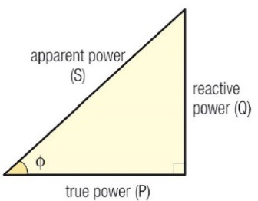
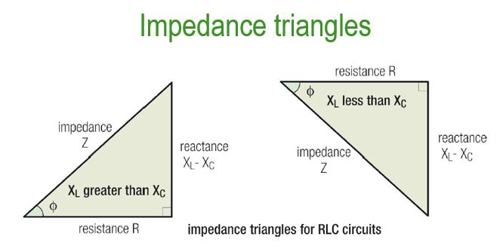
Power Triangle

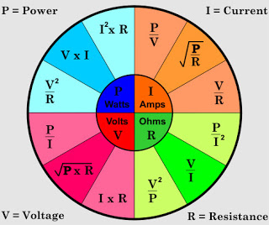

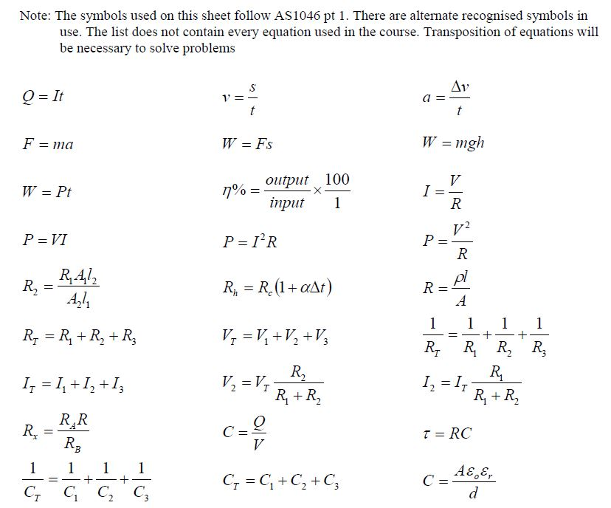

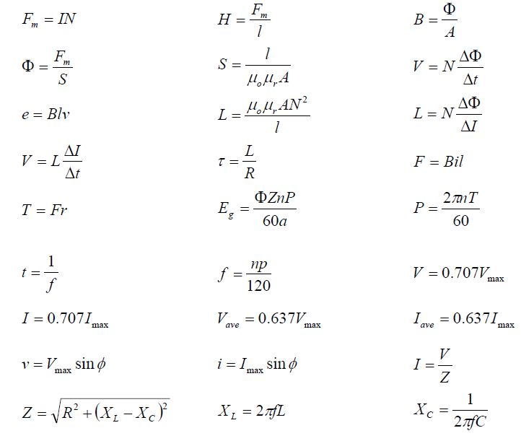
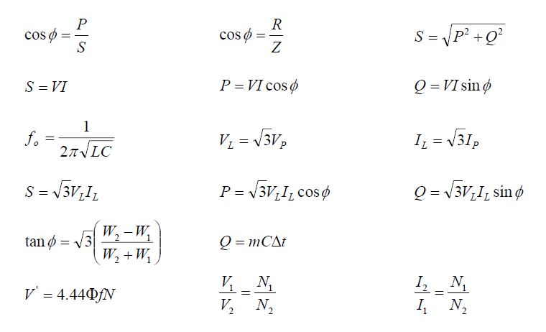
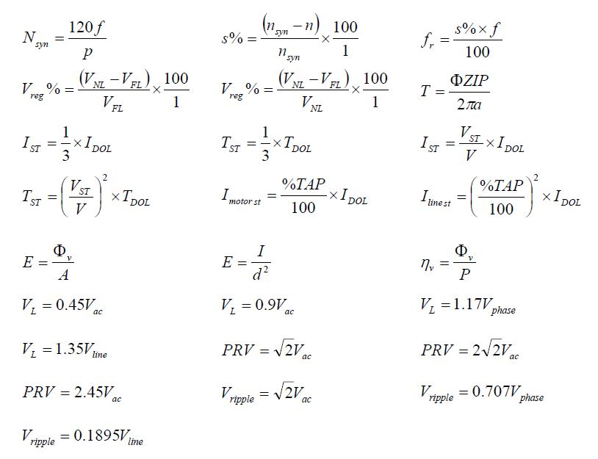
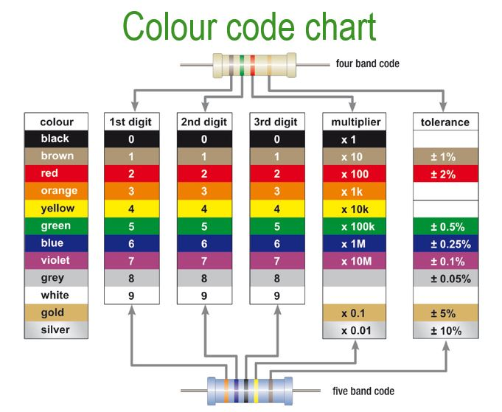

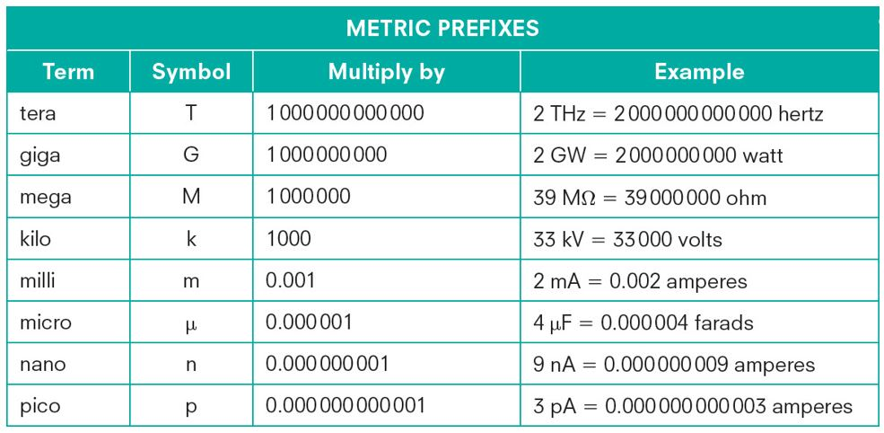

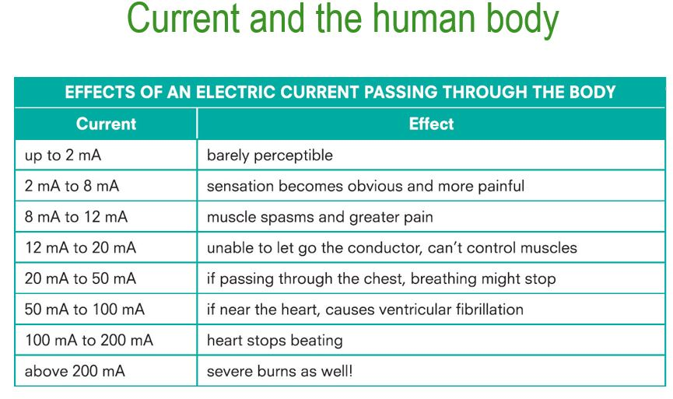
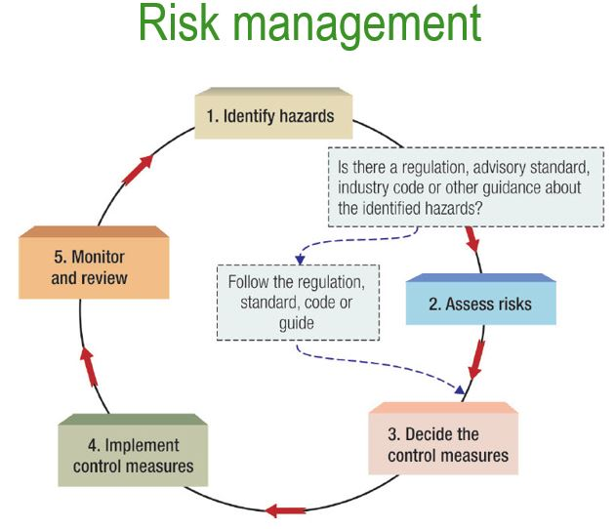
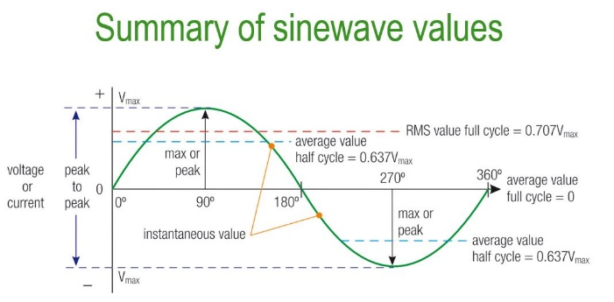
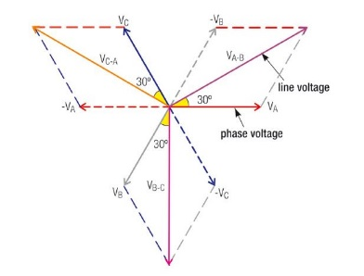
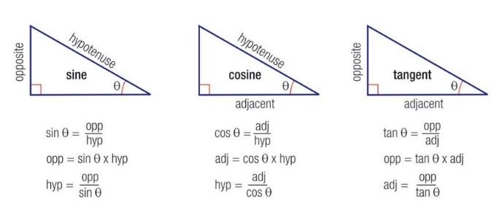
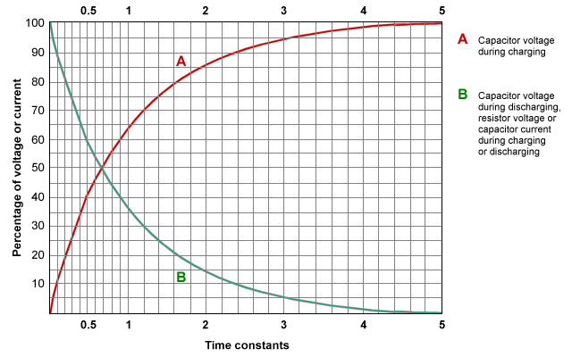

Session #2 Study Plan
AC Lesson #1 Alternating Current Complex Quantities
Trigonometry – Pythagoras - CRO Operation - Sinusoidal Wave Formations

Pre-study | 1 Hour | Remarks
Option A: Read textbook | Textbook Chapter 15.1 -15.4 (page 332) | Read straight through the section once.  Then go back and highlight parts you need to clarify or ask about.
Option B: Watch videos on wired4Imagination.com | Video theory parts 0-4 : Practical Video | Best watched before class

Questions or ideas that I need to ask the teacher about resulting from textbook and or videos
What needs clarification | What did I have no idea about!
Lesson revision questions: 15 minutes
  - A sine wave has a peak to peak voltage of 550 V_{pk-pk}.
Determine the instantons value of voltage at the following angles; Vmax = Vpk=pk/2 = 550/2 = 275v
(a): 45º Sin 45 x 275 = 194V
(b) 130⁰ Sin 130 x 275 =
(c) 272⁰

  - A sine wave has a maximum current of 40 amps at a frequency of 50 Hz.
Determine the instantaneous value of current after the following times; 1/50f = 20 ms period

- 5mS 12/20 x 360 = 216⁰ Sin 216 x 40 = -23.5A
- 11mS 11/20 x 360 =
- 18ms

  - Complete the table below;
RMS Value Vmax * 0.707 | Maximum Value rms/0.707 | Peak-to-Peak Value Vmax *2
10A | 14.14A | 28.29A
10.6V | 15V | 30V
 |  | 17A
230V
 | 22A

  - Carefully review Dr. Kens “How to read an Oscilloscope“. Re-draw the wave form showing how to measure time/frequency and voltage.
Relevant lesson topic quiz to 100% 20 minutes
Learning how to learn in AC : wired4Imagination.com :Cognitive Toolbox #1 Abstract nature of electrical physics: It makes learning hard, very hard for most.
Session #3 Study Plan.
Lesson #2 Phasors Diagrams, Addition and Subtraction
Phasor Diagrams - Phasor Relationship - Using Phasor Diagrams

Pre-study | 1 Hour | Remarks
Option A: Read textbook | Textbook Chapter 15.5 -15.6 (page 346) | Read straight through the section once.  Then go back and highlight parts you need to clarify or ask about.
Option B: Watch videos on wired4Imagination.com | Video theory parts 1-3 : Practical Video | Best watched before class

Questions or ideas that I need to ask the teacher about resulting from textbook and or videos
What needs clarification | What did I have no idea about!
Lesson revision questions: 15 minutes
(2.1) Solve the following by phasor diagram and calculator ; 150V < 43⁰ + 45V< -38⁰ : 76V<230⁰ + 120V<76⁰

(2.2) Solve the following by phasor diagram and calculator ; 230V< 0⁰ + 230V<120⁰ + 230V<240⁰ : 240V<17⁰ + 130V <-45⁰ + 56V<200⁰

Complete Exercise tutorials from this week
Relevant lesson topic quiz to 100% 20 minutes
(Answers : 2.1 = 139V<24⁰ : 61V<109⁰ 2.2 = 0<0 : 272V<-8.7⁰)
Learning how to learn: Time management in 7 steps
1. Start your day with a clear focus.: The first work-related activity of your day should be to determine what you want to achieve that day and what you absolutely must accomplish. Come clear on this purpose before you check your email or smart phone and start responding to queries and resolve issues. Setting a clear focus for your day might require as little as five minutes but can save you several hours of wasted time and effort. 2.Have a dynamic task list.: Capture the tasks and activities you must do on a list and update it regularly during the day. Revisit this list frequently and add new items as soon as they appear. Make sure your list gives you a quick overview of everything that’s urgent and important and remember to include strategic and relationship-building learning activities as well as operational tasks. Time Management Tips From a Pro 3. Focus on high-value activities.: Before you start something new, identify the activity that would have the most positive effect on your learning project, your goal, and if you were to deal with it right now. Resist the temptation to clear smaller, unimportant items first. Start with what is most import. 4. Minimize interruptions.: The more uninterrupted time you get during the day to work on important learning tasks, the more effective you’ll be. Identify the activities that tend to disrupt your learning, and find a solution. For example, avoid checking emails and answering the phone when you’re in the middle of learning. Once you have broken your flow, it can be difficult to re-establish it. Instead, discipline yourself to work on a task single-mindedly until it’s complete. 5. Stop procrastinating.: If you have difficulties staying focused or tend to procrastinate, you may benefit from creating an external commitment or (deadline) yourself. For instance, schedule a meeting in two days’ time where you’ll be presenting your learning and by which time your actions will have to be completed. It’s also very effective to complete the most unpleasant tasks early in the day, and to allow yourself small rewards once you’ve completed them. 6. Limit multi-tasking.: Many of us multi-task and believe we’re effective when we do so, but evidence suggests that we can’t effectively focus on more than one thing at a time. In order to stop multi-tasking, try these tips: Plan your day in blocks and set specific time aside for learning, returning calls to mates and for doing other stuff. Whenever you find yourself multitasking, stop and sit quietly for a minute. Multi-tasking is Killing Your Learning. 7. Review your day.: Spend 5-10 minutes reviewing your task list every day. Give yourself a pat on the back if you achieved what you wanted. If you think your day’s effort fell short, decide what you’ll do differently tomorrow in order to accomplish what you need to. Leave the office or work site in high spirits determined to pick up the thread the next day.

Session #4 Study Plan.
Lesson # 3 Single Element AC Circuits. Pure R,L and C
Resistive AC Circuits - Inductive AC Circuits - Capacitive AC Circuits

Pre-study | 1 Hour | Remarks
Option A: Read textbook | Textbook Chapter 16.1 -16.7 (page 359) | Read straight through the section once.  Then go back and highlight parts you need to clarify or ask about.
Option B: Watch videos on wired4Imagination.com | Video theory parts 1-7 : Practical Videos 1-3 | Best watched before class

Questions or ideas that I need to ask the teacher about resulting from textbook and or videos
What needs clarification | What did I have no idea about!
Lesson revision questions: 15 minutes
(3.1) A purely resistive lamp is connected to a 50v, 50 Hz supply. The lamp draws a current of 2.2 amps. Determine ;
- Circuit resistance R= V/I = 50/2.2 = 22.7 Ohms
- Circuit impedance Lamp is resistive so R = Z =
(c ) Power consumed by the circuit

(3.2) Calculate the capacitance of a motor start capacitor if its capacitive reactance is 110 Ohms at 50 Hz.

Complete Exercise tutorials from this week 20 minutes
Relevant lesson topic quiz to 100% 20 minutes
(Answers : 3.1 = 22.7R : 22.7R : 100W 3.2 = 28.94yF : )
Learning how to learn: History of Electricity
Wired4imagination.com Cognitive Toolbox #3 History of electricity : https://youtu.be/7EW2Y9fHIT8
BBC Video https://www.youtube.com/watch?v=hVu844ZcCdU

Session #5 Study Plan.
Lesson # 4 RC and RL and RLC Series AC Circuits
Impedance - RC series AC Circuits - RL series AC Circuits - RLC series AC Circuits - Impedance and Voltage relationships - Series Resonance

Pre-study | 1 Hour | Remarks
Option A: Read textbook | Textbook Chapter 17.1 -17.4 (page 378) | Read straight through the section once.  Then go back and highlight parts you need to clarify or ask about.
Option B: Watch videos on wired4Imagination.com | Video theory parts 1-4 : Practical Videos 1-3 | Best watched before class

Questions or ideas that I need to ask the teacher about resulting from textbook and or videos
What needs clarification | What did I have no idea about!
Lesson revision questions: 15 minutes
(4.1) A series AC circuit consists of an inductor and a resistor. The voltage drop across the indictor is 220V <80⁰ and the voltage drop across the resistor 125V. Determine the applied voltage, using a phasor diagram and check with a calculator in complex mode.

(4.2) A resistance of 190 Ohms is connected in series with a coil which has an inductance of 0.8H and an internal resistance of 50 Ohms. The circuit is connected to 240v, 50 Hz supply. Calculate the following.
(a) Total Resistance: 190 + 50 = 240R
(b) Inductive reactance: XL = 2 * π * F * L
(c ) Circuit impedance: (Hint impedance triangle)
(d ) Circuit current:

Complete Exercise tutorials from this week 20 minutes
Relevant lesson topic quiz to 100% 20 minutes
(Answers : 4.1 = 271v <53⁰ 4.2 = 240R : XL251R : Z347R : 691mA)
Learning how to learn:
Wired4imagination.com Cognitive Toolbox #5 Managing Distractions
Session #6 Study Plan.
Lesson #5 Parallel AC Circuits.
RC Parallel AC Circuits - LC Parallel AC Circuits - RLC Parallel AC Circuits - Parallel Resonance

Pre-study | 1 Hour | Remarks
Option A: Read textbook | Textbook Chapter 18.1 -18.6 (page 401) | Read straight through the section once.  Then go back and highlight parts you need to clarify or ask about.
Option B: Watch videos on wired4Imagination.com | Video theory parts 1-6 : Practical Videos 1-2 | Best watched before class

Questions or ideas that I need to ask the teacher about resulting from textbook and or videos
What needs clarification | What did I have no idea about!
Lesson revision questions: 15 minutes
(5.1) A parallel AC circuit consists of a heater and a motor. The motor draws a current of 8amps <35⁰ Lag. The heater draws 4.5 Amps. Determine the total current using a phasor diagram and check with your calculator in complex mode.

(5.2) In a parallel circuit there is a resistive load of 30 Ohms, in one branch, and a capacitive branch with a capacitive reactance of 41 Ohms. If the supply voltage is 240v at 50 Hz, determine the total circuit current and draw the phasor diagram also confirm with your calculator in complex mode.
IC = V/Xc = 240/41 = IR = V/R =
(5.3) A resistor of 7 Ohms, a pure inductive reactance of 10 Ohms and a capacitor with a reactance of 15 Ohms are connected in parallel across a 30v ac supply. Draw the phasor diagram to scale and show the following and confirm with a calculator in complex mode for total current; Ic = 24/15= 1.6A <-90 : IL = : IR=

Complete Exercise tutorials from this week 20 minutes
Relevant lesson topic quiz to 100% 20 minutes
(Answers : 5.1 = 12A<-23⁰ : 5.2 = IC =5.85A<90⁰ : IR = 8A <0⁰ : IT= 9.91A <36⁰ : 5.3= IT =7.57<-18⁰ )
Learning how to learn:
Wired4imagination.com Cognitive Toolbox #6 Managing Distractions
Session #7 Study Plan.
Lesson #6 Power in AC Circuits
AC Power - Power Factor - AC Single Phase Power measurement

Pre-study | 1 Hour | Remarks
Option A: Read textbook | Textbook Chapter 19.1 -19.3 (page 419) | Read straight through the section once.  Then go back and highlight parts you need to clarify or ask about.
Option B: Watch videos on wired4Imagination.com | Video theory parts 1-4 : Practical Video 1 | Best watched before class

Questions or ideas that I need to ask the teacher about resulting from textbook and or videos
What needs clarification | What did I have no idea about!
Lesson revision questions: 15 minutes
(6.1) A single phase load require 20kW of power. Determine the rating of the alternator and current carrying capacity of the connecting conductors if the load supply is at 220v and a P.F. of;
(a) Unity (Unity means in phase) 20 kW = 20 KVA: I = VA/V =
(b) 0.75 Lag VA = W/PF =

(6.2) A single phase 210kW load is supplied from a 230V 50 Hz supply. If the current taken by the load is 1000 Amps, determine the power factor. VA = 1000 x 230 =
(6.3) A single phase motor is connected to a 415v, 50 Hz supply and draws 5Amps at a phase angle oh 32⁰ lag. Determine the apparent, true and reactive power taken from the supply and draw the power triangle to scale.
PF = Cos 32 = 0.8
VA = 415 x 5 = 2075 VA
Complete Exercise tutorials from this week 20 minutes : REVISE Lessons #1 - #6
Relevant lesson topic quiz to 100% 20 minutes
(Answers : 6.1 = (a) 20kVA : 90.9A : (b) 26.67kVA : 121A : 6.2 = PF = 0.913 : 6.3 =1660W : 1099VAR : 2075VA )
Learning how to learn:
Wired4imagination.com Cognitive Toolbox #8 Mental Modelling
Sessions #8: Knowledge Assessment #1

REVISE LESSON 1-6
COMPLETE KA#3 TPOICS 1- 7 TO 100% (This is eventually required and a good way to find your learning gaps)

A reminder: Practicing assessment questions for the sake or in the hope of questing for questions sake is a poor approach.
The task is to demonstrate you understand the content, that is the physics.
Practicing questions, then going and researching (filling the gaps) will produce good and abiding understanding.

Warning about open book assessments: If you don’t understand the physics, then you won’t know the answer when you see it. It’s like giving a five-year-old a calculator and asking them to find the square-root of two. They know it’s the right tool, but they don’t understand the mathematical principles required. Learn the physics and use the textbook to confirm your approach, then the probabilities of being correct are very high.

Session #9 Skills Assessment #1
Task A = Single Phase Series Resistors : Task B = Single Phase Series RLC : Task C = Single Phase Parallel RLC
Knowledge Assessment #1 Topic re-sits
15 Minutes per topic + 10 minutes grace.

A reminder: Practicing assessment questions for the sake or in the hope of questing for questions sake is a poor approach.
The task is to demonstrate you understand the content, that is the physics.
Practicing questions, then going and researching (filling the gaps) will produce good and abiding understanding.

Session #10 Study Plan
Lesson #7 Power factor improvement and Harmonics and Resonance revision
Power Factor - Power Factor improvement – Harmonics - Series Resonance - Parallel Resonance

Pre-study | 1 Hour | Remarks
Option A: Read textbook | Textbook Chapter 19.4 -19.5 (page 419) | Read straight through the section once.  Then go back and highlight parts you need to clarify or ask about.
Option B: Watch videos on wired4Imagination.com | Video theory parts 1-3 : Practical Videos 1-2 | Best watched before class

Questions or ideas that I need to ask the teacher about resulting from textbook and or videos
What needs clarification | What did I have no idea about!
Lesson revision questions: 15 minutes
(7.1) A 390 V, 50 Hz single phase installation draws 140 Amps from a supply at a power factor of 0.55 lag. Determine the rating of a capacitor back to be connected in parallel with the load to achieve an installation power factor 0.92 lag. 0.55 Lag = -56⁰ 0.92 = 23.07⁰

(7.2) Determine the value of a static VAR compensator (fixed capacitor) and the line current for a 40 Amp 0.43 PF lag load supplied by 230 V AC at 50 Hz. Power factor to be be improved to 0.86 lag. (Draw the circuit !)

Complete Exercise tutorials from this week 20 minutes : Relevant lesson topic quiz to 100% 20 minutes
(Answers : 7.1 = IC = 83A : 32.4KVAR : 7.2 = IC 25A : 5.75KVAR )
Learning how to learn:
Wired4imagination.com Cognitive Toolbox #11 Calculated Risks
Session #11 Study Plan
Lesson #8 Three Phase Systems Introduction
Multiphase Systems - Three Phase Systems

Pre-study | 1 Hour | Remarks
Option A: Read textbook | Textbook Chapter 20.1 -20.2 (page 436)) | Read straight through the section once.  Then go back and highlight parts you need to clarify or ask about.
Option B: Watch videos on wired4Imagination.com | Video theory parts 1-2 : Practical Video 1 | Best watched before class

Questions or ideas that I need to ask the teacher about resulting from textbook and or videos
What needs clarification | What did I have no idea about!
Lesson revision questions: 15 minutes
(8.1) At what speed must an eight pole three phase alternator be driven to produce a frequency of 60 Hz?
Page 573 of the textbook : F=np/120
(8.3) A three phase alternator produces a maximum voltage of 500V . Determine the instantaneous voltage when the A phase is at a rotational position of 90⁰ .
Determine the position of all three phases in relation to A ay 90⁰.
B Phase is at 90⁰-120⁰ = -30⁰
C Phase is at 90⁰-240⁰ = -150⁰
A phase: v = Sin 90⁰ * 500 =
B phase
C Phase
Complete Exercise tutorials from this week 20 minutes :
Relevant lesson topic quiz to 100% 20 minutes
(Answers : 8.1 = 900RPM : 8.2 = A 500V B-250V C-250v )
Learning how to learn:
Wired4imagination.com Cognitive Toolbox #11 Calculated Risks
Session #12 Study Plan.
Lesson #9 Topic 11&12 Three phase star-connections, Wye, 3&4 Wire.
Star Connected Systems - Star Connected Systems Conditions - Function of Neutral Conductors - Neutral Conductors
Australian Standards Requirements

Pre-study | 1 Hour | Remarks
Option A: Read textbook | Textbook Chapter 20.3 & 20.5 (page 440) | Read straight through the section once.  Then go back and highlight parts you need to clarify or ask about.
Option B: Watch videos on wired4Imagination.com | Video theory parts 1-3 : Practical Videos 1-2 | Best watched before class

Questions or ideas that I need to ask the teacher about resulting from textbook and or videos
What needs clarification | What did I have no idea about!
Lesson revision questions: 15 minutes
(9.1) A three phase distribution transformer is star connected and the supply line voltage of 330V. What is the transformers phase voltage. (Draw the circuit!).
Vp = VL/√3 =
(9.2) A three phase star connected four wire supply has a phase voltage of 220V. What is the line voltage? (Draw the circuit!).

(9.3) A start connected induction motor is connected to a 300 v supply. The motor takes a line current of 26 Amps from the supply. Calculate the impedance of each of the phase windings. Z = Vp/Ip

(9.4) A three phase, four wire supply has the following connected; Determine the value of the neutral current and direction. Draw a diagram!
A – Phase to neutral, 5A resistive load.
B - Phase to neutral, 3A Lag at 70⁰
C – Phase to neutral, 7A Lead at 20⁰
Complete Exercise tutorials from this week 20 minutes :
Relevant lesson topic quiz to 100% 20 minutes
(Answers : 9.1 = 190.5 : 9.2 =381V : 9.3= 6.66R : 9.4 = 6A <-57 )
Learning how to learn:
Wired4imagination.com Cognitive Toolbox #11 Calculated Risks
Session #13 Study Plan.
Lesson #10 Three phase delta-connections, Mesh and Interconnected systems
Delta Connections - Delta Systems

Pre-study | 1 Hour | Remarks
Option A: Read textbook | Textbook Chapter 20.4 (page 444) | Read straight through the section once.  Then go back and highlight parts you need to clarify or ask about.
Option B: Watch videos on wired4Imagination.com | Video theory parts 1-2 : Practical Videos 1-3 | Best watched before class

Questions or ideas that I need to ask the teacher about resulting from textbook and or videos
What needs clarification | What did I have no idea about!
Lesson revision questions: 15 minutes
(10. 1) A delta connected resistive load takes a current of 75 A from the supply. What is the current in each phase?
Ip = IL/√3

(10.2) The phase current in each phase of a delta connected load is 300 Amps. What is the current in the supply lines?

(10.3) A delta connected load has phase impedances of 30 Ohms each. The line currents I_{A} = I_{B} and I_{C} = 100A each. ( Draw the circuit). Calculate; (a) the phase currents and (b) the line voltages

(10.4) A delta connected heater with a 500 W element in each phase is supplied from a three phase, three wire 440 V 50 Hz supply. Determine the current in the heating elements if the fuse in line B has blown. ( Draw it! Ohms law)

Complete Exercise tutorials from this week 20 minutes :
Relevant lesson topic quiz to 100% 20 minutes
(Answers : 10.1 = 43.3 : 10.2 =520A : 10.3 =a- 58A : b- 1.74kV : 10.4 = 1.3A AtoC; 650mA A-B_C)
Learning how to learn:
Wired4imagination.com Cognitive Toolbox #12 Problem Solving
Session #14 Study Plan
Lesson #11 Energy and power requirements of a.c. systems circuits
Three Phase Power - Power Factor

Pre-study | 1 Hour | Remarks
Option A: Read textbook | Textbook Chapter 20.6-20.7 (page 444) | Read straight through the section once.  Then go back and highlight parts you need to clarify or ask about.
Option B: Watch videos on wired4Imagination.com | Video theory parts 1-3 : Practical Video 1 | Best watched before class

Questions or ideas that I need to ask the teacher about resulting from textbook and or videos
What needs clarification | What did I have no idea about!
Lesson revision questions: 15 minutes
(11.1) A three phase 33kV (line voltage) transformer supplies 400kW balanced three phase load operating at 0.8 P.F. lagging. Determine the line current supplied by the transformer. True power 400kW , Apparent Power =

(11.2) Calculate the power factor of a system using two wattmeter method if W1= 30 Kw and W2 = 22kW. Also determine the total power consumed by the system.

Complete Exercise tutorials from this week 20 minutes :
Relevant lesson topic quiz to 100% 20 minutes
(Answers : 11.1 = 15.15A : 11.2 = TP= 52kW , PF = 0.966)
Learning how to learn:
Wired4imagination.com Cognitive Toolbox #15 Reading between the lines
Session #15 Study Plan.
Lesson #12 Earth Fault loop Impedance
Earth Loop Impedance - Australian Standards - Measuring Fault Loop Impedance

Pre-study | 1 Hour | Remarks
Option A: Read textbook | Class Hand-outs | Read straight through the section once.  Then go back and highlight parts you need to clarify or ask about.
Option B: Watch videos on wired4Imagination.com | Video theory parts 0-5 : Practical Video 12b | Best watched before class

Questions or ideas that I need to ask the teacher about resulting from textbook and or videos
What needs clarification | What did I have no idea about!
Lesson revision questions: 15 minutes
(12.1) The supply authorities nominated property supply is fault level at 10kA at 230v. Determine the impedance of the supply. Z = V/I

(12.2) The internal impedance of an installations has been determined at 0.055 Ohms. The supply voltage is 220v. Calculate the fault current internal.

(12.3) The supply authority has nominate a maximum fault level of 20kVA @240v. The internal impedance is measured at 0.280 Ohms. Determine the total earth fault loop impedance. Z = Zint + ZExt

(12.4) Using as 3008 determine the AC resistance at 50Hz of the following conductor.
Conductor is; 6mm² , Cu, multicore TPS V90, at a length of 174m. Answer in Ohms or Milliohms.

Complete Exercise tutorials from this week 20 minutes :
Relevant lesson topic quiz to 100% 20 minutes
(Answers : 12.1 = 23m Ohms : 12.2 =3.2kA : 12.3 =0.292 Ohms : 12.4 = 0.684 Ohms)
Learning how to learn:
Wired4imagination.com Cognitive Toolbox #16 Underpinning Knowledge

Sessions #16: Knowledge Assessment #2

REVISE LESSON 8-15
COMPLETE KA#3 Lesson TPOICS 8- 15 TO 100% (This is eventually required and a good way to find your learning gaps)

A reminder: Practicing assessment questions for the sake or in the hope of questing for questions sake is a poor approach.
The task is to demonstrate you understand the content, that is the physics.
Practicing questions, then going and researching (filling the gaps) will produce good and abiding understanding.

Warning about open book assessments: If you don’t understand the physics, then you won’t know the answer when you see it. It’s like giving a five-year-old a calculator and asking them to find the square-root of two. They know it’s the right tool, but they don’t understand the mathematical principles required. Learn the physics and use the textbook to confirm your approach, then the probabilities of being correct are very high.

Session #17 Skills Assessment #2

Practical Tasks SA#3a & SA#3b.
a= Three Phase Star connections : b = Three Phase Delta connections

Session #18 Clean up and Final Re-sits

Re-sits Knowledge Assessment #1 if not completed with the appropriate part of KA#3 to 100%
Re-sits Knowledge Assessments #2
Final submission for KA#3
Time allowed for re-sits = 15 minutes per topic plus 10 minutes grace.
What is competency-based assessment.

Competency based assessment is to demonstrate a particular level of competency. For electrical trades students this “level” is called Certificate III.

AQF Level 3 – Certificate III
The purpose of the Certificate III qualification type is to qualify individuals who apply a broad range of knowledge and skills in varied contexts to undertake skilled work and as a pathway for further learning..
Certificate III qualifications must be designed and accredited to enable graduates to demonstrate the learning outcomes expressed as knowledge, skills and the application of knowledge and skills specified in the level 3 criteria and the Certificate III descriptor of UEENEEG102A.(Solve problems in AC)
To cut through the Edu speak. Demonstrate learning outcomes as knowledge and skills, is about the theory of the physics in AC normally demonstrated through theory assessments. Application of the knowledge and skills in AC is normally assessed through the practical assessments.
Competency is about showing clear and applicable understanding at every point in the training packages knowledge and skills topics and sub-topics. It is not about 100% or 70% or even 50%. In competency based assessment the students must demonstrate clear competency theoretically and practically at all points.
The problem is that many students are used to a norm-based assessment approach. In this approach an assessment is set up with the understanding that a “normal” student will achieve a certain percentage for content understanding. If the percentage is achieved, they “pass” with reference to the norm. This approach is floored, because there is no “norm”!
Competency based assessment is criterion reference. That is, the assessment is setup to assess every criterion required by the training package. The students must achieve a “successful” at every criterion to have succeeded at the assessment. Once all assessments of theory and practical have been successful, then the student is said to have “achieved competence”. This is the Australian training system.
As an example with AC, UEENEEG102A there are fifteen (15) topic points and an average of eight (8) sub-topics that form the criteria. So an assessment system must cover every point once (and some are required twice) from a theory perspective and once from a practical perspective. This is basically 120+ theory questions in an assessment and the student must get every question right to meet the individual criteria. It is not about 100%. It is about demonstrating competency at every criterion point and within a reasonable time and within two attempts. Similarly, the practical assessments must cover the 120+ criteria again from an application (skills) perspective. The advantage with practical assessment is quite often one exercise (question) covers several criteria at the same time.
So in AC our knowledge assessment #1 has 30 questions, knowledge assessment #2 has 33 questions, KA#3 has 5-10 per topic and no time or attempt limit to allow for the extra or repetitive questions. The Skills assessment SA# A-E have just the right number and type of tasks (questions) to cover the required criterion, no more no less.
The days of norm referenced assessment is well past and you as the student must demonstrate competence at all points and levels of a Certificate III student.

