Assessment Practical/Observation

Student Name |  |  |  | Student #
Competency Title & code  CRN |  | UEENEEG102A Solve problems is low voltage A.C. circuits
Assessment Type |  | ☐ In the workplace ☒ Simulated environment ☐ Other
Assessment Name |  | SA#1 – SA#3
Assessment Date |  | Session #9 (SA#1&2) Session #17 (SA#3)
Student Statement: This assessment is my own work. Any ideas and comments made by other people have been acknowledged. I understand that by emailing or submitting this assessment electronically, I agree to this statement.
Student Signature |  |  |  | Date
PRIVACY DISCLAIMER: RTO is collecting your personal information for assessment purposes. The information will only be used in accordance with the RTO Privacy Policy.
Assessor Feedback (also complete observation checklist and questions on last page)

Student provided with feedback
Successful / Not Yet Successful
Assessor Name |  |  | Assessor Signature
Assessor Note: Please record any reasonable adjustment that has occurred for this assessment.

Assessment Task Instructions for Students:
The practical tasks revolve around single and three phase AC circuits. There are five practical tasks, the first three are associated with single phase series and parallel circuits. The final two tasks related to three phase start and delta systems.

Covering the following topics:
- SA#1a – Single Phase a.c. Circuit – Oscilloscope measurements

- SA#1b – Single Phase Series RLC a.c. Circuit

- SA#2 – Single Phase Parallel RLC a.c. Circuit

- SA#3a – Three Phase Unbalance Star Connected Load

- SA#3b – Three Phase Delta Connected Load

Time Allowed: Single phase tasks 40 minutes each : Three phase tasks 60 minutes each

Assessment Range and Conditions:
The Assessment will be conducted during regular class time in a 4 hour block.
All work must be the students own work
Student may have a copy of AS3000, Textbook “Electrical trade principles”, internet access, equation sheet.
Student must supply their own calculator, pens pencils and drawing equipment.
Student may not use or have access to: smart phone, unit workbook, personal notes.

Assessment Criteria: To achieve a Satisfactory result, your assessor will be looking for your ability to demonstrate the key skills/tasks/knowledge detailed in the Assessment Task to industry standard at all checkpoints.
A result of 100% in every assessment point is a Satisfactory Result. This is a limited open book assessment
You must successfully complete the following skills on the practical observation checklist below:
CIT Unit Skills Test Task Sheet

UEENEEG102A – Solve problems in low voltage a.c. circuits

Task:

- SA#1a – Single Phase a.c. Circuit – CRO measurements (40min)

- SA#1b – Single Phase Series RLC a.c. Circuit (40min)

- SA#2 – Single Phase Parallel RLC a.c. Circuit (40min)

- SA#3a – Three Phase Unbalance Star Connected Load (1hour)

- SA#3b – Three Phase Delta Connected Load (1hour)

Instruction:

- Mobile phones and smart devices must be turned off and not accessed.

- Wait for the assessor to mark your work when requested.

- You will be allowed two (2) attempts at each check point to demonstrate the task described. You may decide to stop at that point and resit in the final resit week at the end of the semester.

- Whilst carrying out skills activities you must follow workplace procedures and ensure efficient/sustainable use of materials.

Check list item | Check points | Satisfactory  Yes / No
Planning the Skills Test | Checkpoint 1
Single Phase a.c. Circuit - measurements | Checkpoint 2
Single Phase a.c. Circuit - observations | Checkpoint 3
Series RLC a.c. Circuit - measurements | Checkpoint 4
Series RLC a.c. Circuit - observations | Checkpoint 5
Parallel RLC a.c. Circuit - measurements | Checkpoint 6
Parallel RLC a.c. Circuit - observations | Checkpoint 7
3 Phase unbalanced star - measurements | Checkpoint 8
3 Phase unbalanced star - observations | Checkpoint 9
3 Phase delta - measurements | Checkpoint 10
3 Phase delta - observations | Checkpoint 11
Completing the Skills Test | Checkpoint 12
Overall result

1: Planning the unit skills test
The assessor will provide you with the details of the equipment required for this skills assessment
Equipment:  - Ammeter  - Voltmeter  - Oscilloscope  - Switch  - Lamp Panel  - Fuses/Circuit Breakers  - Phase rotation meter | Suggested Materials:  - Resistors XXR  - Capacitor XXuF  - Indictor XXXmH  - XXW Lamps | Miscellaneous:  - Variable ELV supply  - Connection leads  - Oscilloscope leads  - 3 Phase ELV supply
Risk Assessment
- Identify any hazards that may exist with this skills practice below

- List the supervision level you will be working under - Direct (D), General (G) or Broad (B)

- List the risk classification – High Risk (H), Medium Risk (M) or Low Risk (L)

- List the control measures required for each identified hazard that you need to implement.

Hazard identification | Supervision level | Risk Classification | Control measures
Electricity |  |  | Isolation

Assessor to check your risk assessment at this point Checkpoint 1

Have the assessor check your risk assessment and provide feedback | Assessor Initials | Assessor dates

2: AS#1a Single phase a.c. series circuit and Oscilloscope measurements

Part A1: Circuit connections and oscilloscope setup

1: Ensure the supply is isolated and then proceed to connect the series resistive circuit and oscilloscope as indicated in Figure 1.
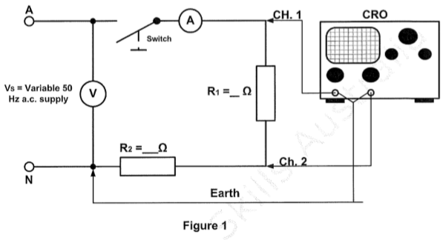
Figure #1
Clamp Meter only

2: Turn on the oscilloscope and wait for it to start up.

3: Once powered up use the [AUTO] button to setup the scaling.

4: Note that you may have to move the horizontals up or down to centre the waves in the centre of the screen.

5: Have the assessor check your work to ensure safety.

2: Continue the Skills Assessment

Part 2A : Circuit measurements

1: Turn on the power source, then close the circuit switch and adjust the supply voltage until the voltmeter indicates 26V. (Typical V RMS A-N).

2: Measure the total current – IT (RMS value) through the circuit and record in Table 1

TABLE #1
Attempts | Voltage V | Current mA | Vp-p R1 | Vp-p R2 | Period mS
1st
2nd

3: Measure the circuit current and record in table #1

4: Measure the peak to peak voltage of the applied supply using the oscilloscope and determine the voltage drop across R1 and record in table #1.

5: Measure the peak to peak voltage drop using the oscilloscope across resistor R2 and record in Table 1.

6: Measure the periodic time of the voltage drop waveform across resistor R2 and record in table #1

7: Have the assessor check your results in table #1 then proceed to the next step (Checkpoint #2)

Have the assessor check measurements | Assessor Initials | Assessor dates

2: Continue the Skills Assessment

Part A3: Interpreting the measurements

1: Using the results from Table 1, determine the following circuit parameters:

- Maximum voltage drop across resistor R1

- The frequency of the voltage drop waveform R2

- The instantaneous value of voltage at 120 degrees R1

- The RMS value of voltage drop across R2

2: Have the assessor check your observations before proceeding to the next Task of the Unit Skills Test. (Checkpoint 3)

Have the assessor check your results | Assessor Initials | Assessor dates

2: AS#1b Single phase a.c. series RLC circuit

Part B1: Circuit connections RLC a.c. circuit

1: Arrange and connect in a neat and logical manner the circuit in Figure #2.

Clamp Meter only
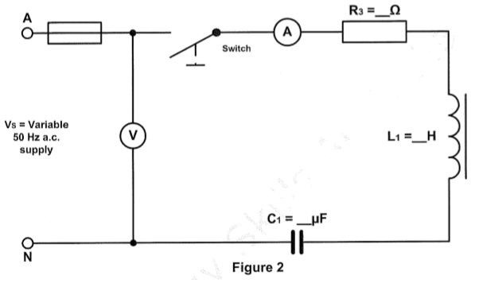

2: Have your assessor check your connections for safety before proceeding in in doubt.

2: Continue the Skills Assessment

Part B2 : Circuit measurements – Series RLC circuit

1: Turn on the power supply source, adjust the supply until the voltmeter indicates 26V (Our typical A-N supply), and then close the circuit switch.

2: Measure the total circuit current and voltage drops across each component and record in Table 2. NOTE: currents measured with camp-ammeter only.

TABLE #2

Attempts | Supply Voltage V | Current mA | Voltage Drop - Volts
Attempts | Supply Voltage V | Current mA | VR | VL | VC
1st
2nd

3: Have the assessor check your circuit measurements in Table 2 before proceeding to the next step. (Checkpoint 4)

Have the assessor check your results | Assessor Initials | Assessor dates

2: Continue the Skills Assessment

Part B3 – Interpreting measurements

1: Using the results from Table 2, answer the following:

(a ) In the series RLC circuit shown in Figure 2, what are the dangers if this capacitive reactance equals the inductive reactance components?

(b) Using the results obtained in Table 2, draw the phasor diagram for the series RLC circuit to scale.



(c) Using the diagram, determine the phase angle of the circuit : [ ]

2: Continue the Skills Assessment

(d ) Using the results from table #2 determine the total impedance of the circuits?

(e ) Using the results from table #2 determine the power consumed by the circuits?

(f) Using the measured and calculated values from Part B (Table #2), draw the impedance triangle and label all sides and angles.

2: Continue the Skills Assessment

(g) Using the measured and calculated values from Part B (Table #2), draw the power triangle and label all sides and angles.

(h) Referring to Figure 2, if the inductor L1 developed a short-circuit, draw and label the impedance triangle and phasor diagram for the series circuit.

2: Continue the Skills Assessment

(h) Referring to Figure 2, if the capacitor C1 developed a short-circuit, draw and label the impedance triangle and phasor diagram for the series circuit.

2: Have the assessor check your observations before proceeding to the next Task of the Unit Skills Test. (Checkpoint 5)

Have the assessor check your answers | Assessor Initials | Assessor dates

3: AS#2 Single phase a.c. parallel RLC circuit

Part C1: Circuit connections parallel RLC a.c. circuit

1: Arrange and connect in a neat and logical manner the circuit in Figure #3.

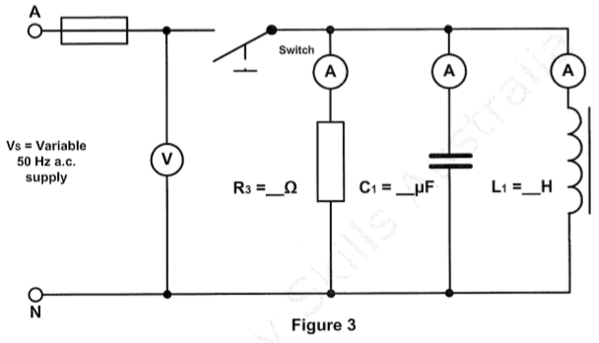
Clamp Meter only

2: Have your assessor check your connections for safety before proceeding if in doubt.

3: Continue the Skills Assessment

Part C2 : Circuit measurements – Parallel RLC circuit

1: Turn on the power supply source, adjust the supply until the voltmeter indicates 26V (Our typical A-N supply), and then close the circuit switch.

2: Measure the total circuit current and voltage drops across each component and record in Table 3. NOTE: currents measured with camp-ammeter only.
TABLE #3

Attempts | Supply Voltage V |  | Branch currents- mA
Attempts | Supply Voltage V |  | IR | IL | IC
1st
2nd

3: Have the assessor check your circuit measurements in Table 3 before proceeding to the next step. (Checkpoint 6)

Have the assessor check your results | Assessor Initials | Assessor dates

Part C3: Interpreting measurements

1: Using the results from table #3, answer the following;

- In the parallel RLC circuit shown in Figure 3, what are the dangers if this capacitive reactance equals the inductive reactance and resonance occurs

3: Continue the Skills Assessment

(b) Using the results from table #3 draw the phasor diagram for the parallel RLC circuit to scale?

(c ) Using the phasor diagram above determine the following;

(i) Total circuit current : [ ]; and

(ii) Circuits phase angle: [ ]

2: Have the assessor check your observation before proceeding. (Checkpoint 7)

Have the assessor check your answers | Assessor Initials | Assessor dates

4: AS#3a Three phase a.c. unbalanced load

Part D1: Circuit connections Three Phase Unbalanced load

1: Arrange and connect in a neat and logical manner the circuit in Figure #4. Z1-Z4 are 40W lamps. F1-F3 is the power supply circuit-breaker.
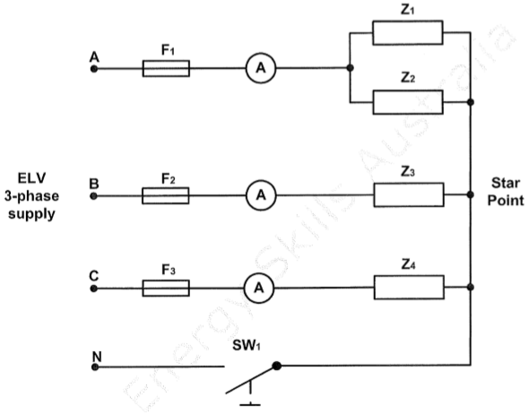
Figure 4
Clamp Meter only

2: Have your assessor check your connections for safety before proceeding if in doubt.

4: Continue the Skills Assessment

Part D2 : Circuit measurements

1: Check the phase rotation of the three phase supply and record the sequence: ABC or ACB.

2: Ensure SW1 is closed and measure and record the line currents readings in table #4. Note: measured with camp-ammeter only
TABLE #4
Star Unbalanced Load – Neutral Connected
Current | Attempt #1 | Attempt#2
IA

IB

IC

3: Open the switch (SW1) and measure the line voltage to star point voltage (VBS and VCS) [ NOT the neutral] for each phase and record in table #5.

TABLE #5
Star Unbalanced Load – Neutral Disconnected
Voltage | Attempt #1 | Attempt#2
VAS

VBS

VCS

4: Isolate the supply and have the assessor check your circuit measurement.
(Checkpoint #8)

Have the assessor check your measurements | Assessor Initials | Assessor dates

4: Continue the Skills Assessment

Part D3 – Interpreting measurements
1: Using the results from Table #4 and Table #5 answer the following;

(a) List two (2) method to reduce or cope with harmonics in a three phase 4 wire system.

(b) State the AN/NZS 300 Wiring Rules requirement for the size of the neutral conductor, when substantial harmonic currents are present. You must quote the clause number:

4: Continue the Skills Assessment

(c) Using the results obtained in Table 4, draw the phasor diagram of the line currents IA, IB and IC for the star connected load to scale. On your phasor diagram draw a phasor representing the neutral current (IN) using the three line current phasors. Record the out of balance neutral current in the box provided.

NEUTRAL CURRENT : A < Degrees

4: Continue the Skills Assessment

(d) Using the results obtained in Table 5, draw the phasor diagram of the three voltages VAS, VBS and VCS for the unbalanced star connected load to scale. On your phasor diagram, draw a phasor to represent the voltage difference between the supply neutral and the star point. Record the value of the voltage difference in the box provided.
.

Voltage difference :

4: Continue the Skills Assessment

(e): Determine the voltage drop of the supply cables to a three phase 4 wire unbalanced load using the AS/NZS 3008.1.1 resistance and reactance tables for the following cable installation: 100 mm² single core copper X-90 cables installed on cable trays and touching each other. The length of the cable run is 80 metres and the line current is 50 amperes.

(f) Using your local Service and Installation Rules for the ACT, what is the minimum power factor allowed for a LV installation less than 100 kVA? (You may use a device to search the internet).

(g): Using manufacturer catalogues, select the most appropriate power factor equipment to correct the 400 V installation pf to 0.9 lag when the installation requires 10 kVAr corrections. (You may use a device to search the internet).

2: Have the assessor check your observation before proceeding. (Checkpoint 9)

Have the assessor check your answers | Assessor Initials | Assessor dates

5: AS#3b Three phase a.c. Delta connected Load

Part E1: Circuit connections Three Phase Delta Load

1: Arrange and connect in a neat and logical manner the circuit in Figure #5. Z1-Z3 are 40W lamps. F1-F3 is the power supply circuit-breaker.

Figure 4
Clamp Meter only
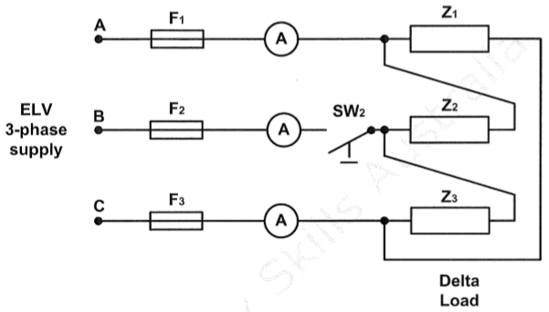
Figure #5

2: Have your assessor check your connections for safety before proceeding if in doubt.

5: Continue the Skills Assessment

Part E2 : Circuit measurements

1: Ensure SW2 is closed, then energise the circuit and measure and record the currents (IA, IB,IC) in table #6. Note: measured with camp-ammeter only.
TABLE #6
Line Currents: Delta Connected balanced load
Current | Attempt #1 | Attempt#2
IA

IB

IC

2: Isolate the supply and open the switch (SW2) and then turn the supply back on.

3: Measure and record the line currents (IA, IB, IC) into table #7

TABLE #7
Delta connected – Open circuit B Phase – Neutral Disconnected
Current | Attempt #1 | Attempt#2
IA

IB

IC

4: Isolate the supply and have the assessor check your circuit measurement.
(Checkpoint #10)

Have the assessor check your measurements | Assessor Initials | Assessor dates

5: Continue the Skills Assessment

Part E3 : Interpreting measurements

1: Using the results from Table #6, #7, answer the following;
(a): Calculate the current in each load (IP) of Figure 5, using the results from Table 6. Record these values in Table 8.

TABLE #8
Phase Currents: Delta Connected - balanced load
Current | Attempt #1 | Attempt#2
Load Z1

Load Z2

Load Z3

(b): Calculate the current in each load (IP) of Figure 5 when SW2 is open, using the results from Table 7. Record these values in Table 9.

TABLE #9
Phase Currents: Delta Connected – Open Circuit B Phase
Current | Attempt #1 | Attempt#2
Load Z1

Load Z2

Load Z3

(c): Calculate the voltage across each lamp when SW2 is open the live voltage is 44V. Recoded this in Table #10
TABLE #10
Load voltage (SW2 open) | Attempt #1 | Attempt#2
V Load Z1

V Load Z2

V Load Z3

5: Continue the Skills Assessment

(d) Using manufacturer websits select the most appropriate measurement equipment to measure the following parameters for the circuit shown in Figure 5: power, energy and power factor. ( NHP : Schneider etc.)
.

(e): On the graph paper below, draw the circuit diagram of a three phase star connected alternator, supplying a three phase delta connected transformer, which in turn supplies a three phase star motor.

5: Continue the Skills Assessment

(f) Calculate the rms values of voltage generated in each phase of the star connected alternator if the maximum peak value generated is 566 volts. (Draw the diagram)

2: Have the assessor check your observation before proceeding. (Checkpoint 11)

Have the assessor check your answers | Assessor Initials | Assessor dates

6: Continue the Skills Assessment

Return all tools and equipment to their correct places and clean the work area .

1: List two (2) methods of improving power factor of a three phase inductive installation.

2: What would be the effect of reversing one phase winding on a star connected three phase alternator?

3: Within the ACT you cannot dichromate in the workplace on the basis of many characteristics. An example is to discriminate is on the basis of age in the workplace.
List two others. (You may search the web if required).

2: Have the assessor check your answers. (Checkpoint 12)

Have the assessor check your answers | Assessor Initials | Assessor dates

