PRE-AC Diagnostic Knowledge Test
Time Allowed 30minutes
Test designed to be diagnostic for the underpinning requirements for AC

Student Name Date

Section A : Basic Physics

1: Factors affecting resistance
There are four factors that affect resistance there are and are measured in what units

Factor | Measurement Units
Length | meters
Cross Sectional Area | m2
Temperature | Degrees C
Permeability p | Ohms/m3

2: Factors affecting capacitance;
From the list below select the appropriate factors.

Factors | Tick if factor
Type of conductor used to make the plates
Cross Sectional Area of the plates | x
Thickness of the insulator
Material use for the dielectric | x
Distance between the plates | x
Distance between the leads

3: Factors determining inductance
From the list below which are not factors that determine inductance.
Factors | Tick if not
Cross Sectional Area of the wire | x
Total number of turns
The permeability of the wire | x
Length of the coil
Cross Sectional Area of the coil
Length of the coiled wire | x
The Core type used

4: Describe lenz’s law.

The current induced in a conductor will set up a magnetic field that opposes the magnetic field causing the current.
Part B: Circuit analysis

Determine a), b), c) and d)
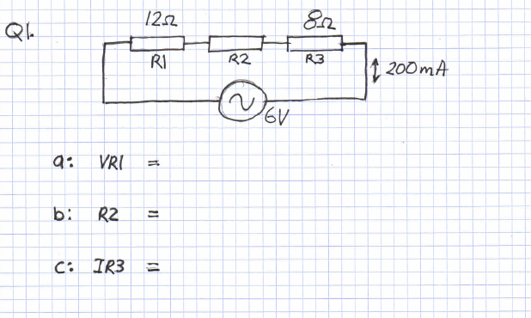
Q1.

Answer:
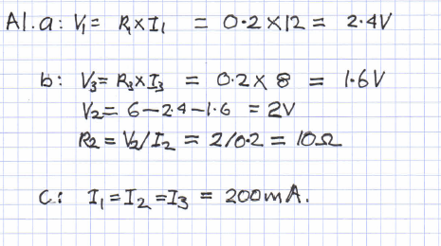

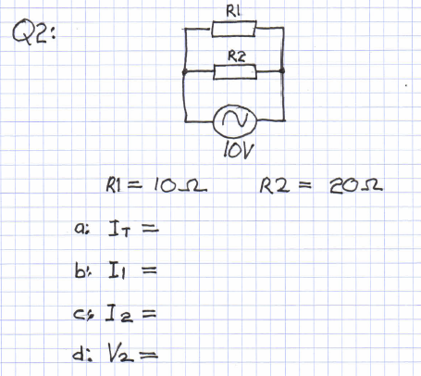
Q2.

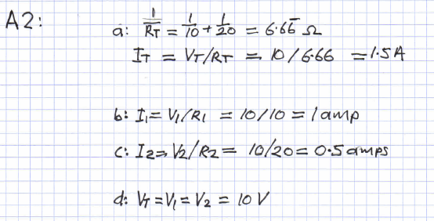
Answer:

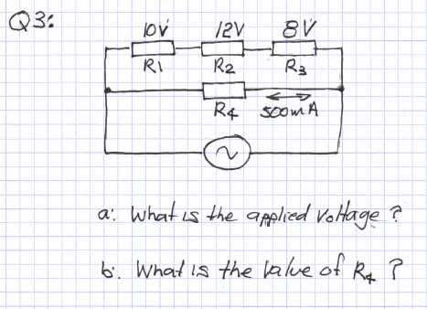
Q3:

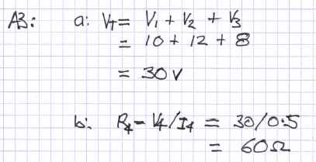
Answer:

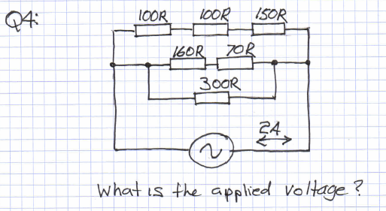
Q4:

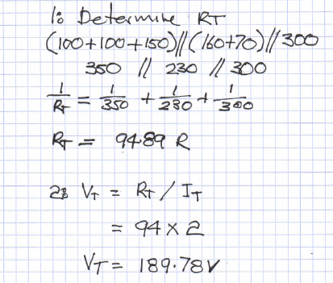
Answer:

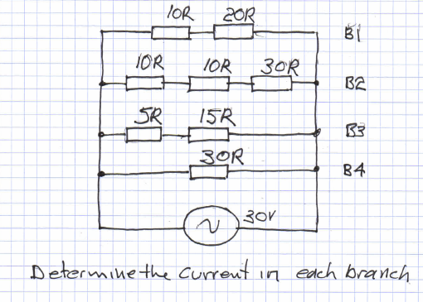
Q5:

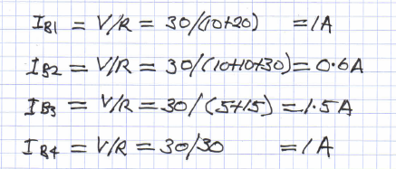
Answer:

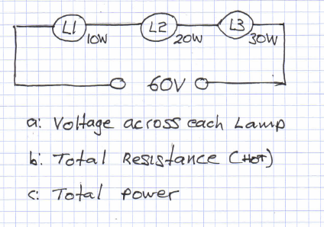
Q6:

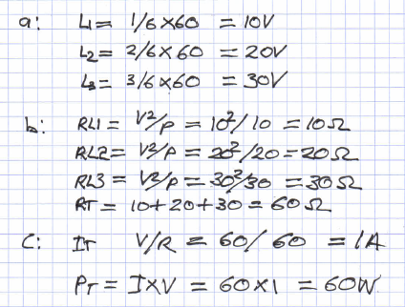
Answer:

Q7:

Answer:
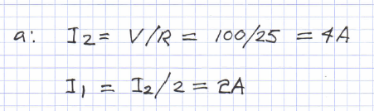

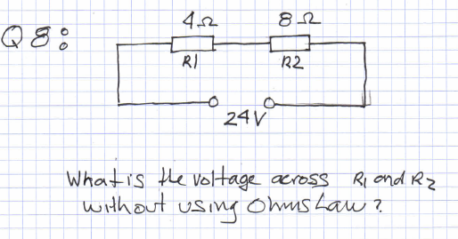
Q8:

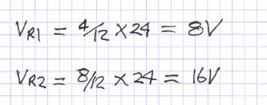
Answer:

Section C : Definitions and Differences
Q1:

Quantity | Definition | Differences
Applied voltage | Supply voltage from a source that cant normally be easily adjusted | Not caused by current, but normally chemical or mechanical energy being converted.
Voltage drop | Caused by current as it passes through the resistance of a component. | The result of work done. Or electrical current changing energy form.
Potential voltage | The ability to case electrons to flow.

Q2:
Quantity | Definition | Units of measure
Electrical current | The flow of free electron between atoms. | Amperes
Resistance | Opposition to current flow. | Ohms
Inductance | Opposition to current flow caused by the changing magnetic field. | Henry’s

Q3:

Quantity | How is energy stored? | Units of measure
Capacitor | Electrostatic field in the dielectric. | Amperes
Resistance | Is not stored but converted to heat. | Ohms
Inductor | Electromagnetic field created by the coils fields combining. | Henry’s

