PRE-AC Diagnostic Knowledge Test
Time Allowed 30minutes
Test designed to be diagnostic for the underpinning requirements for AC

Student Name Date (Ability /50)

Section A : Basic Physics

1: Factors affecting resistance
There are four factors that affect resistance there are and are measured in what units

Factor | Measurement Units

2: Factors affecting capacitance;
From the list below select the appropriate factors.

Factors | Tick if factor
Type of conductor used to make the plates
Cross Sectional Area of the plates
Thickness of the insulator
Material use for the dielectric
Distance between the plates
Distance between the leads

3: Factors determining inductance
From the list below which are not factors that determine inductance.
Factors | Tick if not
Cross Sectional Area of the wire
Total number of turns
The permeability of the wire
Length of the coil
Cross Sectional Area of the coil
Length of the coiled wire
The Core type used

4: Describe lenz’s law.

Part B: Circuit analysis

Determine a), b), c) and d)
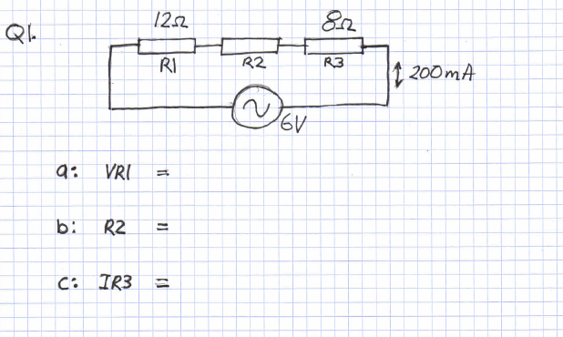
Q1.

Answer:

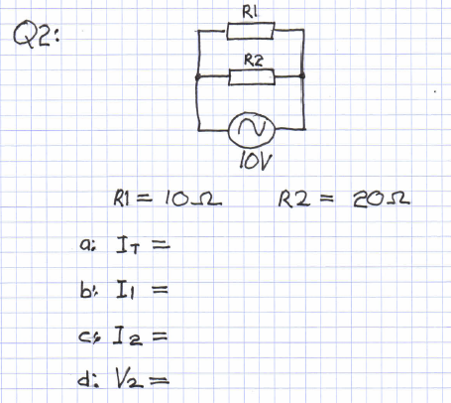
Q2.

Answer:

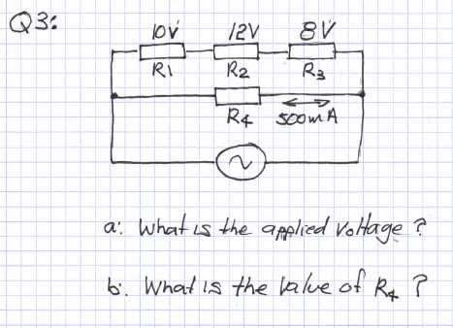
Q3:

Answer:

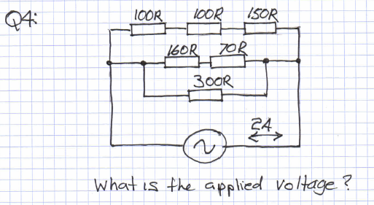
Q4:

Answer:

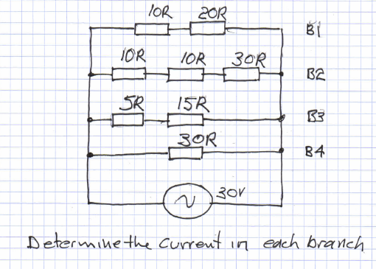
Q5:

Answer:

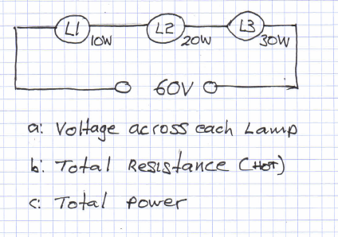
Q6:

Answer:

Q7:

Answer:

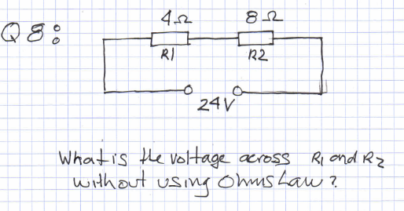
Q8:

Answer:

Section C : Definitions and Differences
Q1:
Quantity | Definition | Differences
Applied voltage
Voltage drop
Potential voltage

Q2:
Quantity | Definition | Units of measure
Electrical current
Resistance
Inductance

Q3:

Quantity | How is energy stored? | Units of measure
Capacitor
Resistance
Inductor

